Lab 1: IAM

Create user

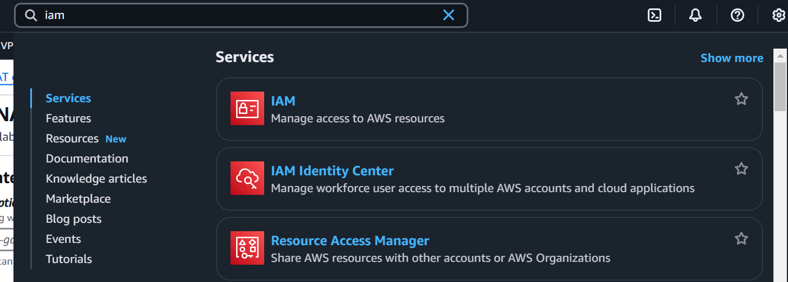

Click on users, and create user

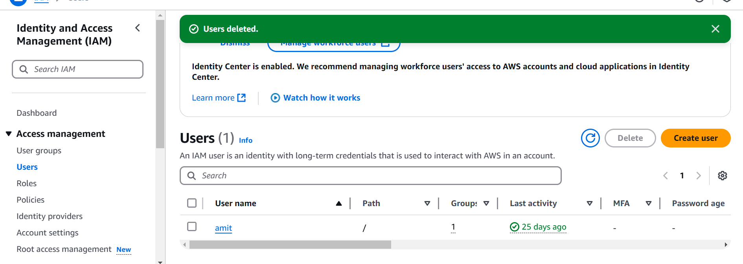

Provide below option

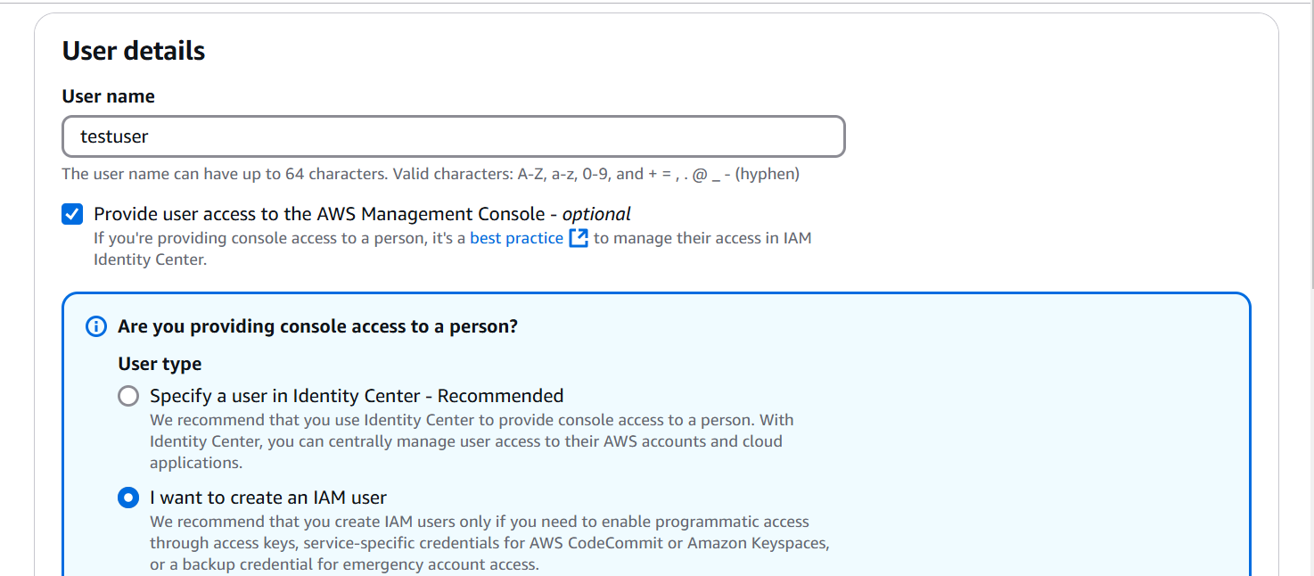

Select auto generated password

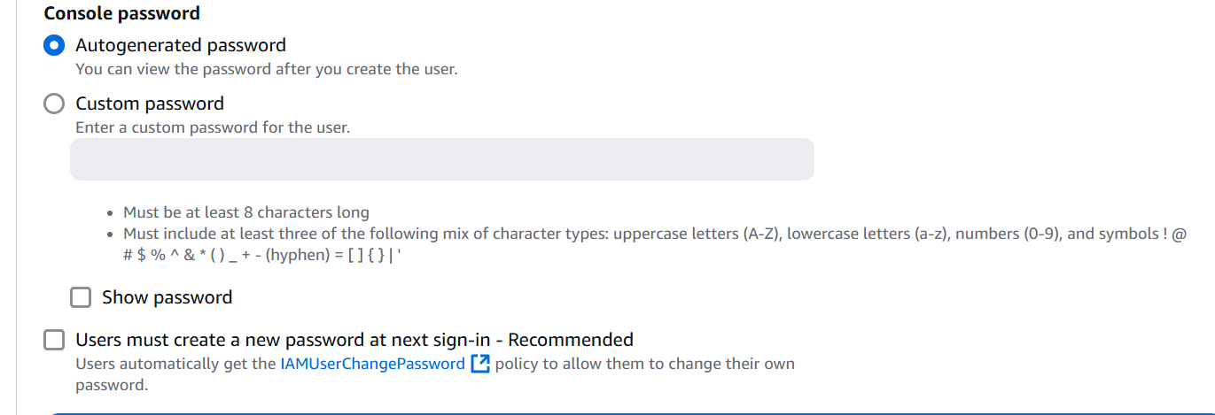

Add user to group option

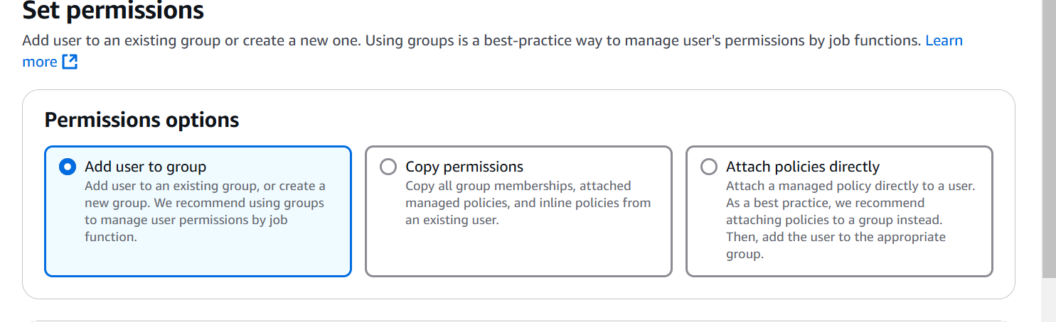

Note: Don’t map the user to any group

Copy below information in your notepad

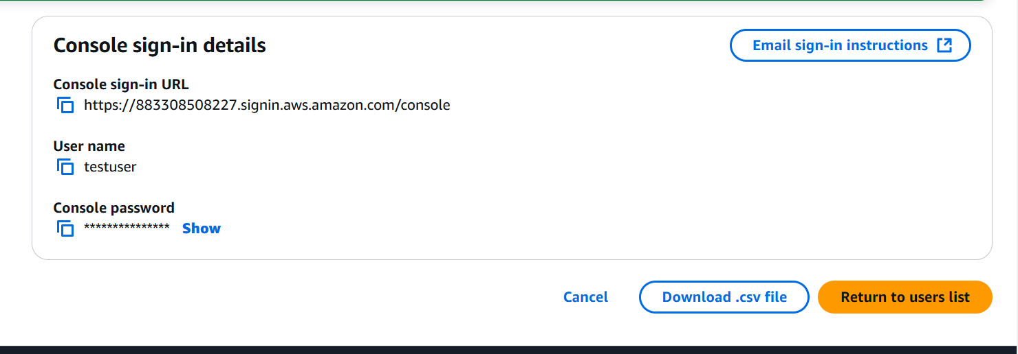

Open Private/incognito mode

Access through url provided above

After login you will get error

